**Sphinx User Manual**

First, open cmd with administrator privileges, use Win + R, then use Ctrl + Shift + Enter to create a new working folder, and use CD your/path/of/file to enter the folder directory, execute the following statement, do not set parameters first, and use the default value to initialize the program:

1. sphinx-quickstart

This will create a source folder with conf. Py files and a main document index. Rst.

Execute the following statement in the current directory to generate a Web page in the./build/HTML folder:

1. make html

To regenerate the page after the change, perform the following:

1. make clean
2. make html

# Index. Rst document

The main function of the main document is to serve as the main interface, and it contains the root of the "toctree", in which other documents can be indexed to achieve links between documents (note that the document name is indexed here, the document name may not be the title name, and the final displayed directory is the title name). The maxdepth parameter indicates the maximum depth of the directory tree. The final directory index will be displayed on the main interface. By default, all levels of index files will be included. Examples are as follows:

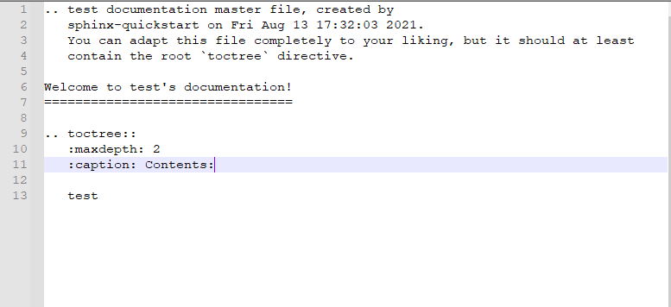

Where test is the name of the file to be indexed, Welcome to test's documentation!! It is a welcome speech and can be changed by yourself. You can precede toctree with the following statement:

1. .. figure:: images/0-1.png
2. :align: center

Note that at least one blank line should be left above and below, which is a fixed format.

Where images/0-1.png is the relative path of the image, relative to the path of the source folder, the align parameter indicates the position where the image is inserted, the default is left alignment, and the center is centered.

At the same time, you can also customize the input text and subtitles on this page, and the format will be described later.

# conf.py

An example of a conf. Py file is as follows:

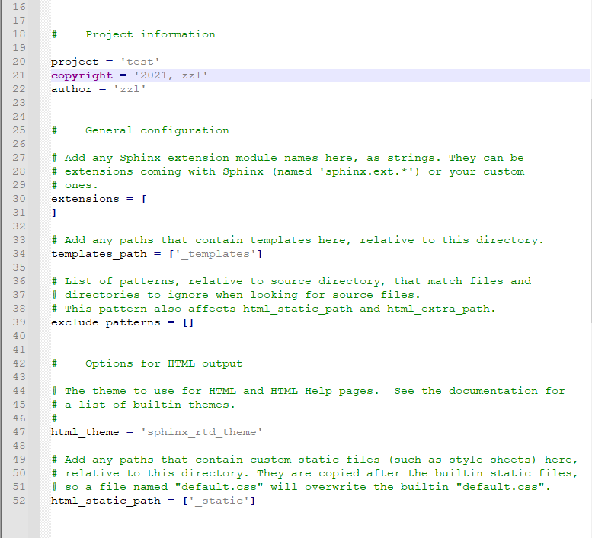

Among them, project represents the subject name, which can be set by yourself, and is the 'test' here;

Copy rigt is the copyright notice, which is' 2021, zzl '. Will be displayed at the bottom of the page as follows:

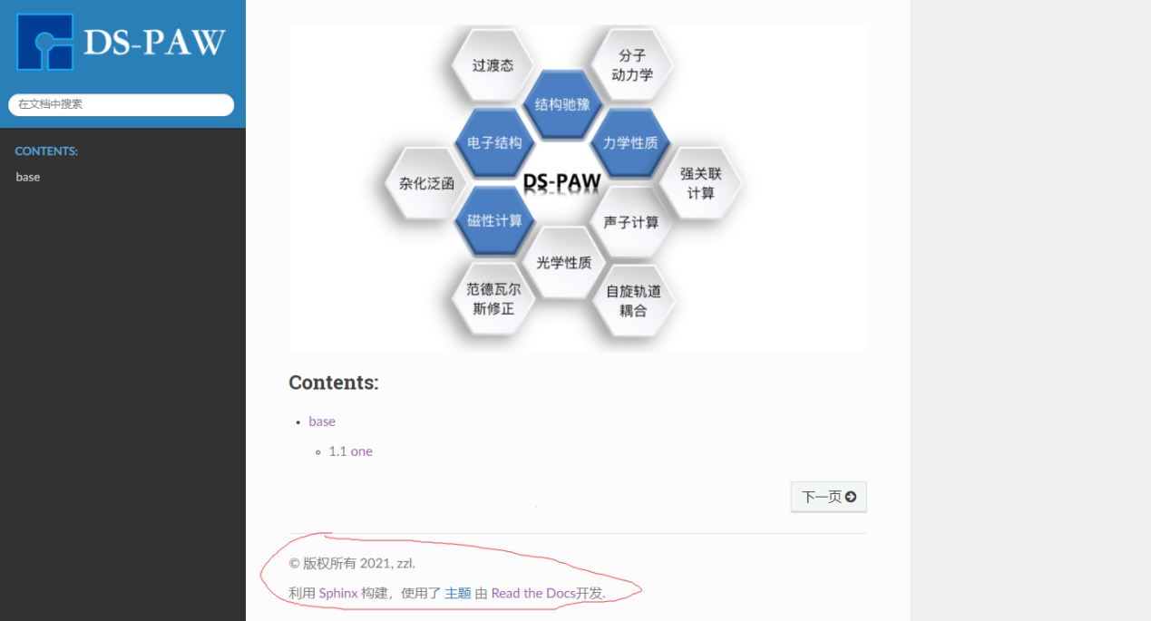

The author is the author, and this is the 'zzl';

The default language is English. To set Chinese, you need to add a command:

1. language = 'zh'

The HTML _ theme is set for the template. The default value is the 'alabaster'. Here, it is the'sphinx _ RTD _ theme '.

If you want to replace the icon in the upper left corner, you can set HTML _ logo with the following command:

1. html_logo = "_static/DS-PAW.png"
2. html_theme_options = {'logo_only': True}

Where, the "_ static/DS-PAW. PNG" is the path of the new logo image, and the second command represents that only the logo of the image is displayed instead of the original default icon. ".

# .rst file

The.rst file is the one that writes the content of the web page, which is linked by the toctree index in the index. Rst file. Where the syntax is still valid at the index. Rst.

"." (there is a space here that cannot be omitted) is followed by an identification statement, which indicates the type of the thing written below. A blank line should be written below it. This is a fixed format. Generally, the second line is a parameter line.

## Title division

1. First-level title

In general, a file is a header, and the header is used by adding the following statement in the.rst file:

1. Title name (serial number can be added)
2. **\*\*\*\*\*\*\*\*\*\*\***

The length of "* * * * *" is at least 4, which is generally longer than title name (if it is shorter than title name, there will be a warning that it is too short, but it will not affect the result).

The. _ base: blank line in the example does not seem to have any effect after testing, and its presence or absence does not affect any distribution of the web page.

1. Secondary title

The second-level title is similar to the first-level title, except that "=" is added under the title. Similarly, the minimum length is 4.

1. Third-level title

The third level heading is changed to "--" and the rest is the same as above.

## Grid line setting

The dividing line at the top of each page will be automatically generated without setting. For the dividing line setting in the text, use "--". The length is the same as the length of the characters under the title. The display result is shown in the following figure:

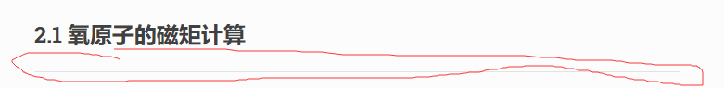

## Code snippet declaration

The code snippet declaration uses the following statement:

1. .. code-block:: python
2. task = scf
3. sys.symmetry = false
4. sys.structure = structure.as
5. sys.spin = collinear
6. cal.smearing = 1
7. cal.sigma = 0.01
8. cal.kpoints = [1, 1, 1]

The code must be indented by at least one space.. In code-block: python, python is the code type, which can be replaced by other common codes. Terminating a code snippet is simply a matter of entering text on a blank line after the code snippet at the same location as the code snippet declaration line.

## Text and symbol settings

1. Dot settings

For the solid dot symbol before the text, it needs to be marked with "*" or "-", and the text needs to be written in the blank space after it. For a subtitle in which a hollow dot can be considered as a solid dot, it is necessary to make a blank line in the next line of the solid dot, and then mark it with "*" or "-". At this time, the position of "*" or "-" relative to the solid dot needs to be indented by more than two spaces. Examples are as follows:

1. * 111
2. - 1111

The results are as follows:



1. Text mark

For the text in the text, there are three ways to mark it, which are Redding, bolding and tagging. (Note: Use these characters with spaces before and after them.)

1. Turn red

"Use" "text" "to make the text red. Character example:"

1. Used in this `dss` calculation

Display results:



1. Bold

Use * * text * * to make the text bold. Character examples:

1. * * Tetrahedron plus Bloch * * method

Display results:



1. Add tags

Use: guilabel: `literal` to add tags, character example:

1. When using this method: guilabel: `sigma`

Display results:



## Add a note

Use Note: You can add an annotation. The code example is as follows:

1. .. note::
2. 1. Parameters of the * * \ io type play a role only in structural relaxation and self-consistency, e.g., io. Charge will not generate Rho. Bin or Rho. JSON files in other computational cases; * *
3. 2. * * In the structural relaxation and self-consistency, the data of elf and potential can also be saved by setting the io. Elf and io. Potential to true; * *
4. 3. * * If You want to use your own optimized structure, you only need to specify the relax. JSON under the absolute path or relative path for the sys. Structure parameter in the calculation, or you can copy the relax. JSON file to the directory of this calculation. Set sys. Structure =./relax. JSON; * *
5. 4. * * Detailed explanation of the calculation case of the spin system NiO case in Chapter 2. **

The results are as follows:

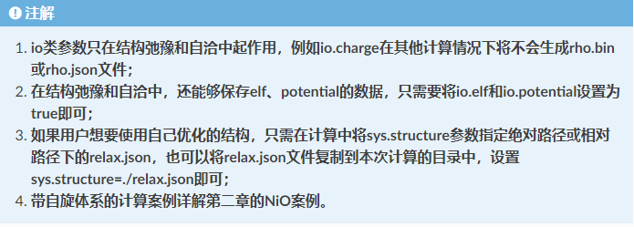

1.2.3.4. in the code can be replaced by (1) (2) (3) (4) without affecting the display results, or can not be marked.

## Add a picture

Images can be stored in a folder under a source directory, such as image (which can be any new folder).

1. .. figure:: images/1-3.png

Set the image to be inserted, where images/1-3.png is the path of the image to be inserted, and a blank line is also required below it.

## Add a table

+------------+------------+------------+------------+-------------+---------------+ | 1579.742 | 621.046 | 621.046 | 0.000 | 0.000 | 0.000 | +============+============+============+============+=============+===============+ |1579.742 | 621.046 | 621.046 | 0.000 | 0.000 | 0.000 | | | | | | | | +------------+------------+------------+------------+-------------+---------------+ | 621.046 | 1579.742 | 621.046 | 0.000 | 0.000 | 0.000 | | | | | | | | +------------+------------+------------+------------+-------------+---------------+ |621.046 | 621.046 | 1579.742 | 0.000 | 0.000 | 0.000 | +------------+------------+------------+------------+-------------+---------------+

## Subscript, e.g. H2O

|  |
| --- |
| H :sub:`2` O |

Superscript, such as E = mc2

|  |
| --- |
| E = mc :sup:`2` |

## In-line formula: $\hat{H}ψ=Eψ$

|  |
| --- |
| :math:`\hat{H} \psi = E \psi` |

Single-line formula, the formula starts on another line and is centered by default:

$$\hat{H}ψ=Eψ$$

|  |
| --- |
| .. math::  \hat{H} \psi = E \psi |

Cross-row formula

|  |
| --- |
| .. math::  (a + b)^2 &= (a + b)(a + b) \\  &= a^2 + 2ab + b^2 |

## Hyperlink insertion

## Set the hyperlink through ` ` _, < > link the URL inside the angle brackets, effect: Github<https://www.github.com>

|  |
| --- |
| `Github <https://www.github.com>`_ |

For the internal anchor point, you need to set the label of the anchor point first, and mark it with an underscore _ + string.

|  |
| --- |
| .. _my-label:  Section to cross-reference  -------------------------- |

Need to customize a text

|  |
| --- |
| This is the text of the section.  It refers to the section itself, see :ref:`text <my-label>` |

Reference to other independent pages

|  |
| --- |
| :doc:`Input Library` |

A reference to a formula

Insert a reference label on a template formula

|  |
| --- |
| .. math::  :label: math-multi  (a + b)^2 &= (a + b)(a + b) \\  &= a^2 + 2ab + b^2 |

Then reference by label:

|  |
| --- |
| :eq:`math-multi` |

## Literature citation:

Need to install plugin: pip install sphinxcontrib -bibtex

Add the appropriate literature information in the refs. Bib.

You only need to insert the corresponding bib index when referencing, as shown in

|  |
| --- |
| :footcite:p:`doi:xxxxx/xxxxxx` |

Cross-page document indexing is not supported, so you need to insert at the end of the current text

|  |
| --- |
| .. footbibliography:: |

**(XII) Markup Grammar**

|  |
| --- |
| .. warning:: This is an optional title  Warning mesage.  Warning message paragraph 2. |

Other marker types:

.. Attention: attention

.. Danger: danger

.. Error: error

.. Hint: hint

.. Important: important

.. Note: annotation

.. Tip: Tips

.. Warning: warning

1. **File download link**

|  |
| --- |
| : download: `download link < files/input. Zip > ' |

Inside the angle brackets is the download link, and outside the angle brackets is the text of the link